Firebrand flux

186 m

0 m

320 m

FBP X

FBP Y

FBP Z

FCS X

FCS Y

FCS Z

Fire line

Road

320 m

160 m

300 m

250 m

150 m

100 m

50 m

Forest fire simulations

Wind field development

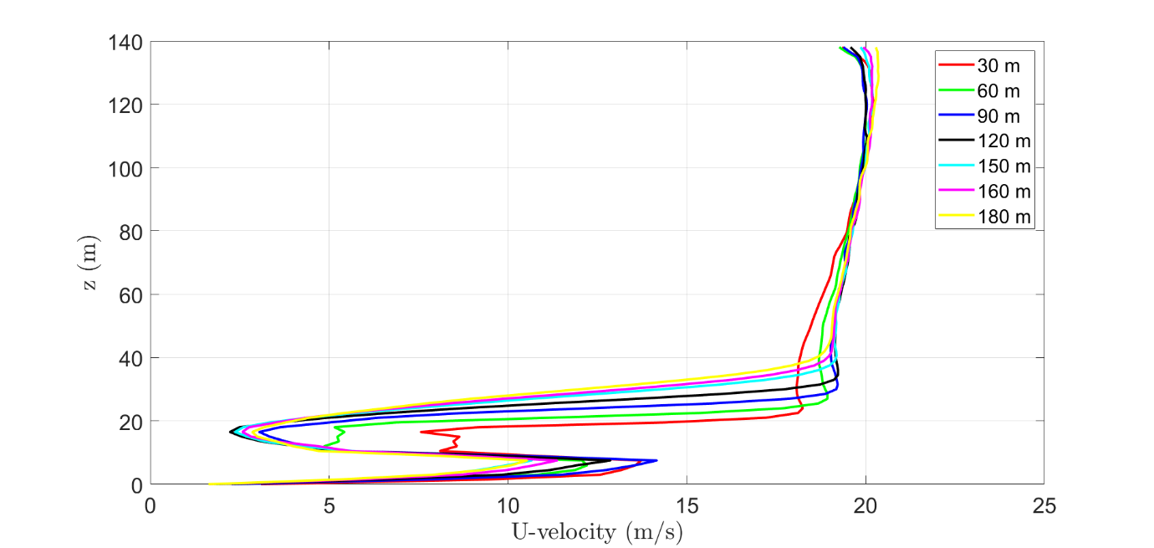

Note: Fire has been started(at 120 s). Particle inputting has been started(at 130 s). Current simulation time is 141 s.

Collection time span (s)

FCS X – 407 s

FCS Y – 513 s

FCS Z – 394 s

|  |  |  |  |  |  |  |  |  |  |
| --- | --- | --- | --- | --- | --- | --- | --- | --- | --- |
| Case | Wind velocity  (m/s) | Particle velocity  (U,V,W) m/s | Input rate pcs/s | **Flux (pcs/m2. s)** | | | **Number of Firebrands(pcs)** | | |
| FCS Z | FCS Y | FCS X | FCS Z | FCS Y | FCS X |
| T H- grid(1.5 m) | ≈2.0 | (8.3, 0.0, 2.1) | 11006 | 1.465 | 1.302 | 0.701 | 577 | 668 | 285 |
| T valid- grid(0.75 m) | ≈2.2 | (8.3, 0.0, 2.1) | 11006 | 1.946 | 0.977 | 0.798 | 767 | 497 | 325 |
| Experiment | 1.4±0.6 | NA | NA | 1.361 | 0.902 | 0.824 | 536 | 463 | 335 |
| Difference(%)  (Exp /T valid) |  |  |  | 30.1% | 07.6% | -03.3% | 30.1% | 07.6% | -03.3% |

Total amount of firebrands landed in the experiment =536+463+335

=1334 pcs

Total amount of firebrands landed in the experiment =767+497+325

=1589 pcs

Difference =16%

Comparison of firebrand flux at X, Y and, Z location in the experiment and the simulation.

|  |  |  |  |  |  |  |
| --- | --- | --- | --- | --- | --- | --- |
| **Area**  **(x 10-5)[m2]** | **Firebrand flux at collection sites (pcs/m2.s)** | | | | | |
| **Experiment** | | | **Simulation** | | |
| **FCS X** | **FCS Y** | **FCS Z** | **FCS X** | **FCS Y** | **FCS Z** |
| **0.75 - 5** | 0.6483 | 0.6858 | 1.0473 | 0.7969 | 0.9164 | 1.1488 |
| **5 - 10** | 0.1034 | 0.1352 | 0.1873 | 0.0014 | 0.0416 | 0.2917 |
| **10 -20** | 0.0537 | 0.0618 | 0.0856 | 0.0000 | 0.0107 | 0.0303 |
| **20 -30** | 0.0054 | 0.0075 | 0.0236 | 0.0000 | 0.0047 | 0.1415 |
| **30 - 50** | 0.0081 | 0.0043 | 0.0118 | 0.0000 | 0.0016 | 0.1967 |
| **>50** | 0.0054 | 0.0075 | 0.0059 | 0.0000 | 0.0024 | 0.1375 |

|  |  |  |  |  |  |  |
| --- | --- | --- | --- | --- | --- | --- |
| **Area**  **(x 10-5)[m2]** | **Firebrand number at collection sites (pcs)** | | | | | |
| **Experiment** | | | **Simulation** | | |
| **FCS X** | **FCS Y** | **FCS Z** | **FCS X** | **FCS Y** | **FCS Z** |
| **0.75 - 5** | 264 | 352 | 413 | 266 | 470 | 453 |
| **5 - 10** | 42 | 69 | 74 | 1 | 21 | 115 |
| **10 -20** | 22 | 32 | 34 | 0 | 5 | 12 |
| **20 -30** | 2 | 4 | 9 | 0 | 2 | 56 |
| **30 - 50** | 3 | 2 | 5 | 0 | 1 | 78 |
| **>50** | 2 | 4 | 2 | 0 | 1 | 54 |

**Firebrand flux: Experiments vs simulation at X, Y, Z locations**

|  |
| --- |
|  |
|  |
|  |

Firebrands inputting number into the domain vs time

|  |
| --- |
|  |

Firebrands accumulation at X, Y, Z locations with time

|  |
| --- |
|  |

Firebrands accumulation total at X, Y, Z locations based on the shape

|  |
| --- |
|  |

Total input number of firebrands (170 s) = 440 240 pcs

Total landed number of firebrands at X, Y, Z locations (300 m2) = 13 955 pcs

Landing percentage =(13 955 pcs/440 240 pcs) x 100

=3.17%

Heat release rate(MW) and Mass loss rate(kg/s)

Average heat release rate (MW) = 2391 (from 122 s to 170 s)

Firebrands inputting rate = 11006 pcs/s

Firebrands inputting rate vs fire intensity = $\frac{11006\frac{pcs}{s}}{2391 MW}$

$=4.60\frac{pcs}{MW. s}$

Douglas fir tree

Average heat release rate (MW) = 3.396 [11.6 s to 26.4 s: where HRR reached 300 kW]

Total firebrands’ input (pcs) =350 pcs within 32 seconds

Firebrands inputting rate (pcs/s) =23.33 pcs/s

Firebrands inputting rate vs fire intensity = $\frac{10.99\frac{pcs}{s}}{3.396 MW}$

= $3.22\frac{pcs}{MW. s}$